/\* Ashok IPBC- SDLC lab 7.10.19\*/

1. What it is SDLC?

* SDLC is a systematic process all are winning software and joins the quantity and cry last OPS Software we’re a

1. Explain the different roles involved in the process.
2. Subject matter experts (SME) or Domain experts

He/She is a senior-level arson with Superior knowledge technology product and business process

 2. Product owner

Product owner is software development role for a person who represents the business or users and it's responsible for working with the use Group to determine what features will be in the product release

Product owner act as main point of contact for all the decision concerning the project

3.Project manager

Project manager is responsible for knowing the “who what when and why” of the software project

 project manager is also responsible for creating and managing the project budget and schedule as well as process including scope management, issue and risk management

Project manager lead and manage project team and also provides regular updates to higher-ups

4. Technical lead

He/ She helps to translate all business requirements to technical Solutions.

Technical lead development team leader and works with developers to provide technical details and estimation of proposed Solutions.

5.Software developer

Software developers develop the actual project as per defined software requirements specifications and Design document specifications

6.Software tester

He or She, test the software against the SRS/DDS and file any bug, error or defects for Developers to solve.

3. Why is it used?

* It offers a basis for project planning, scheduling and estimation
* It is a mechanism for project tracking and control
* it increases and enhance the development speed
* It helps to reduce project risk and project management plan overhead

4. \* 3 Important Facts

Project initiation

Project initiation involves the following actions:

* An original, profitable idea is recognized and a cost justification is made. Initial security objectives are defined.
* Timelines for the project are identified.
* The potential users are contacted and involved in the concept development.
* Security objectives that the software needs to meet.
* Initial risk analysis is performed to see if an alternative approach might be beneficial.

Functional design

Functional design involves the following actions:

* A project plan is developed.
* Security activities and checkpoints are identified.
* Design documentation is developed.
* Some limited resources are allocated to the project. The security framework iscreated.
* The evaluation criteria is identified.
* The framework of the application is designed and a prototype of the most critical components is implemented.

System Design

System design identifies the:

* Functional model
* Behavioral model
* Informational model

Key output from the system design includes:

* Data design
* Procedural design
* Architectural design

Video(s) to Submit:

1. SQL BI Interview Questions: SQL Explain Clustered and Non Clustered

Link: I don’t know how to get link for video but I have photo copy of that.

<https://app.colaberry.com/app/ipbc/videos?user=31221&category=30>

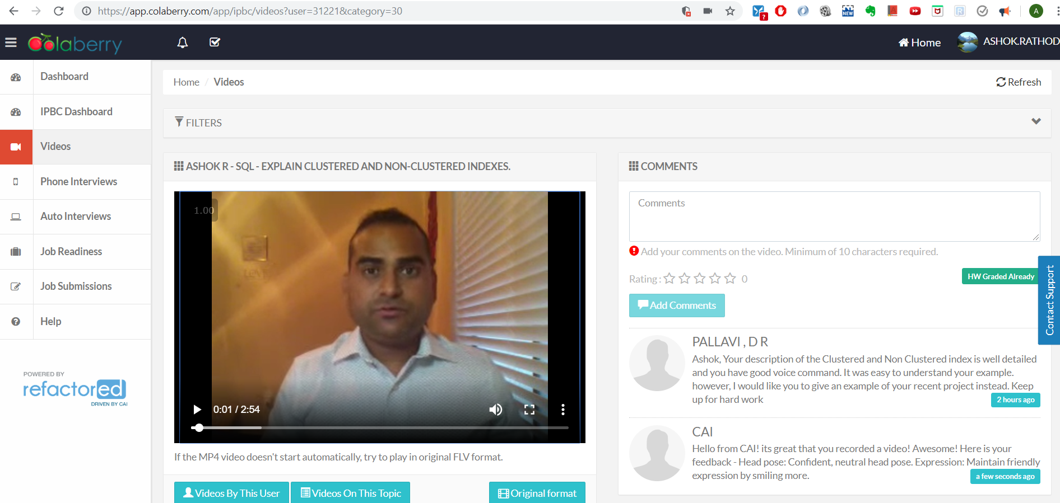

What to Submit:

1.Copy and paste the link to your video(s) as part of your homework.

Link: <https://app.colaberry.com/app/ipbc/videos?user=31221&category=30>

1. Watch, Comment &amp; take screenshots of your comments from 3 other videos on the same topic (per question). Comments must be 20+ characters. Leave comments based on presentation, delivery and/or technical details. Your critiques will help you be more conscious of your own videos. (3 comment screenshots per Video Question)

